Sunday, August 07, 2016
11:51 AM

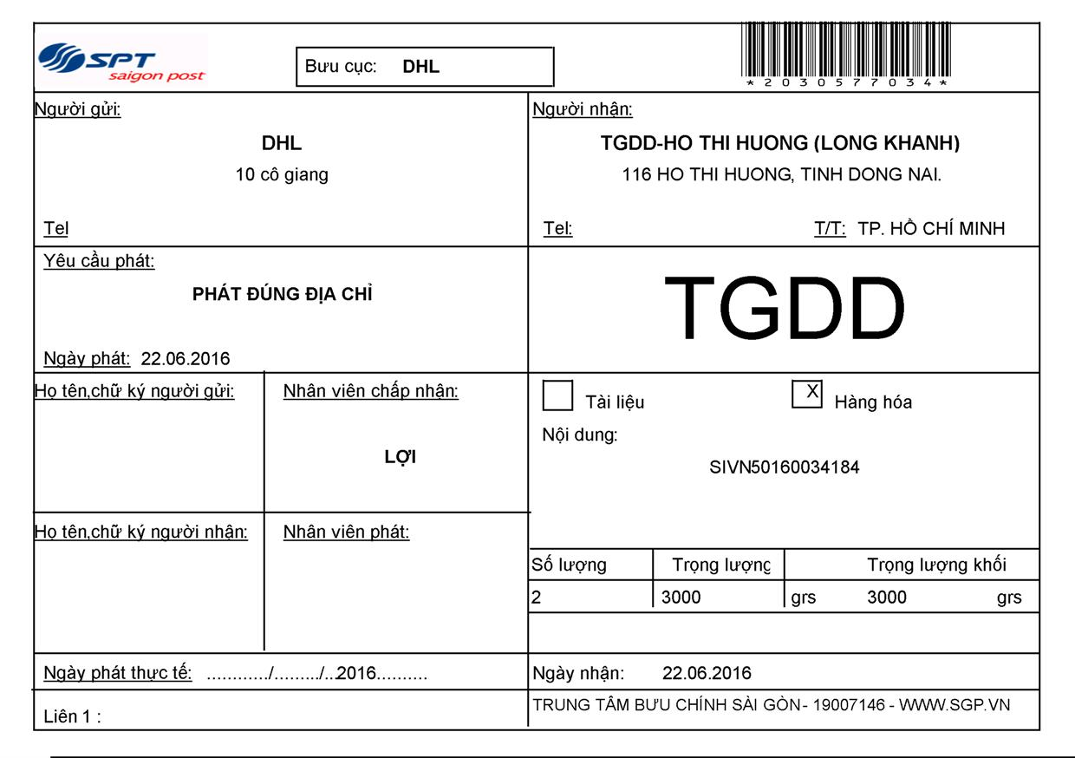

Sunday, August 07, 2016
12:42 PM

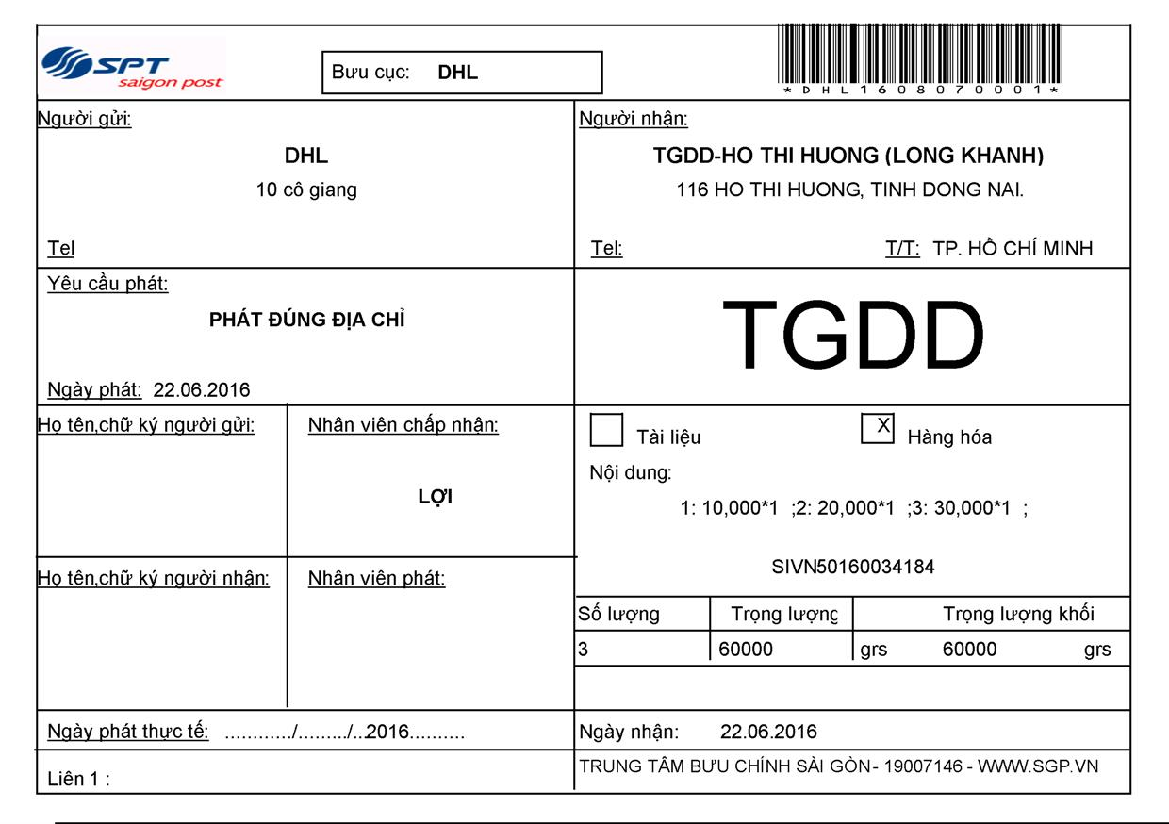

Sunday, August 07, 2016
12:47 PM

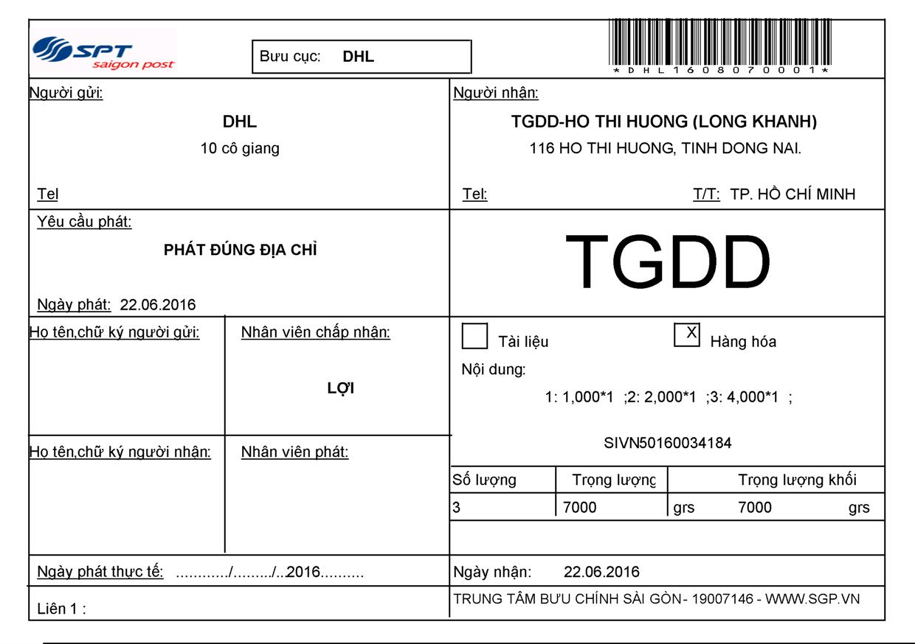

Sunday, August 07, 2016
1:16 PM

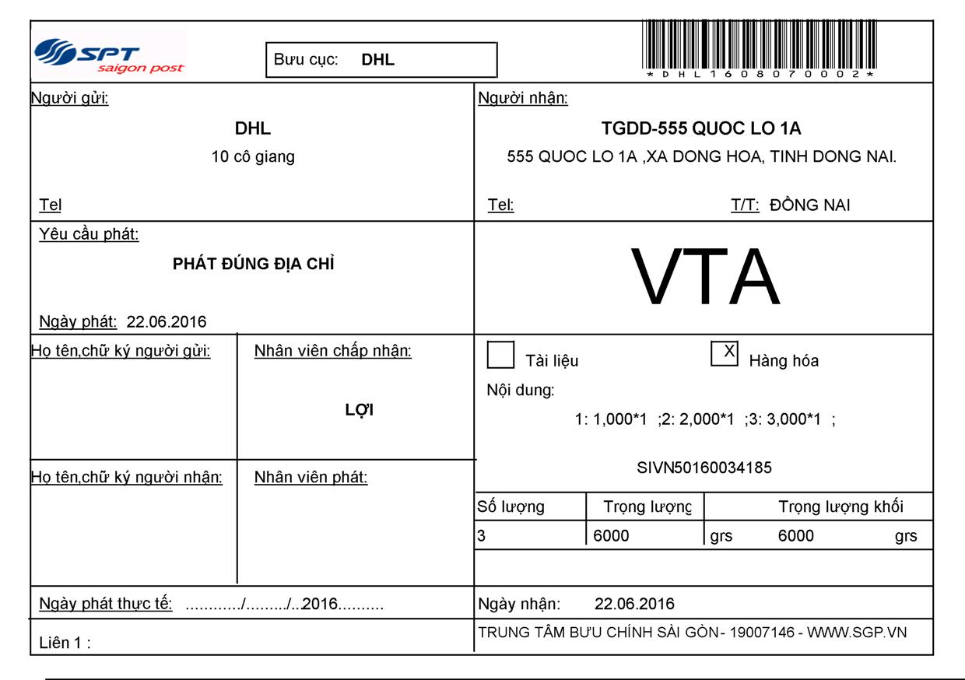

Sunday, August 07, 2016
1:18 PM

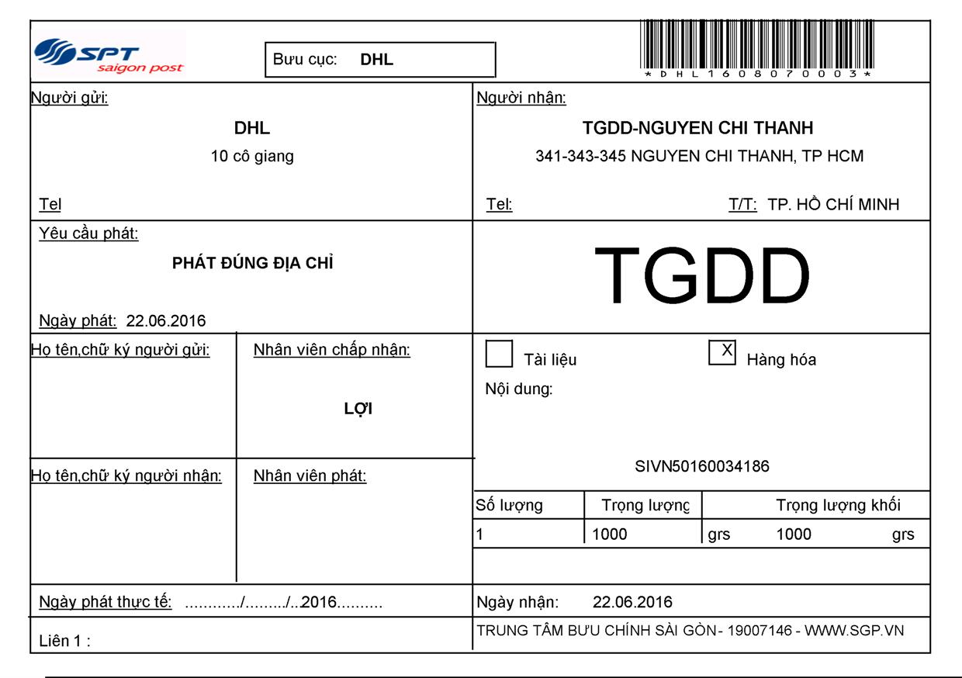

Sunday, August 07, 2016
1:47 PM

